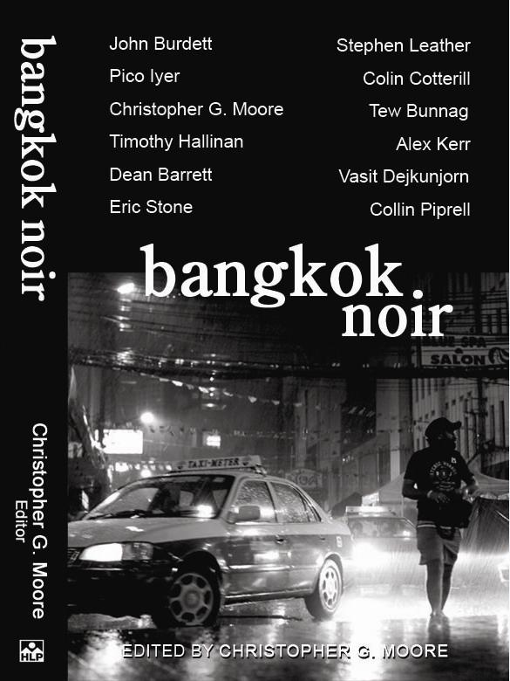
bangkok noir
Edited by Christopher G. Moore

B-Format | Baht 450 | Pages: 289
ISBN: 978-616-7503-07-2
Publisher: Heaven Lake Press
Publication date: February 28, 2011

The Authors of Bangkok Noir

John Burdett
Stephen Leather
Pico Iyer
Colin Cotterill
Christopher G. Moore
Tew Bunnag
Timothy Hallinan
Alex Kerr
Dean Barrett
Vasit Dejkunjorn
Eric Stone
Collin Piprell

Bangkok is one of the great cities in the world, but unlike other great metropolises, it has no noir tales to its name. Bangkok Noir puts that to right.
In the first-ever noir anthology of Bangkok, twelve seasoned and internationally known Thai and Western writers have come together to make a powerful collection of crime fiction short stories that portray the dark side of a Asian metropolis where the lives of most citizens seem as far away from heaven as its Thai name, Khungthep, is distant from its meaning – City of Angels.
In Bangkok Noir, the twelve short stories of various shades of black involve gangsters and hitmen, love and betrayal, the supernatural, the possessed and the dispossessed, and the far distant future. Titles in this collection include: John Burdett’s Gone East, Stephen Leather’s Inspector Zhang and the Dead Thai Gangster, Tew Bunnag’s The Mistress Wants Her Freedom, Colin Cotterill’s Halfhead, Pico Iyer’s Thousand and One Nights, and Christopher G. Moore’s Dolphin Inc.
The authors and publisher will donate half of their earnings from this book to selected charity organizations which provide education to needy children in Thailand.
Official book launch

The Foreign Correspondents’ Club of Thailand (FCCT)
8.00pm, 17 March 2011

Book signing

Kinokuniya, Siam Paragon Branch
3.00pm–6.00pm, 2 April 2011

For more information, please visit www.bangkoknoir.info.

